* 

Activities

|  |  |  |  |  |
| --- | --- | --- | --- | --- |
| **Name of Topic:**  ***Value proposition Customer understanding and Customer segments*** | | | | |
| **Event: Webinar Enter4All** | | | **Trainer: Stratigon** | |
| **Session nº: 10** | | **Duration: 2h** | | **Date:  29.03.2023** |
|  | | | | |
| **Activities:** | * Presentation:   Folder: [Activity No.4_Delivery of 24 tailor webinars (12monthsX2)](https://stratigon.sharepoint.com/:f:/s/STRATIGONFINANCE-TeamEnter4All/Eqi2SOH1nepLtFNYZupHIh0BEI913EgdDO3wcOgOjdIjGw?e=vVKXQr)   * Brainstorming * Videos:  1. <https://www.youtube.com/watch?v=ReM1uqmVfP0&ab_channel=Strategyzer>  * Further Examples of Understanding  1. To παράδειγμα της Apple:   Value Proposition: “The best experiences. Only on Apple.”  Tagline: “Think Different.”   1. Το παράδειγμα της Headspace - <https://www.headspace.com/>  * Case Study: **“Shore Coffee Shop - A SHORE WAY TO A SURE THING ”** - <https://shorecoffee.weebly.com/value-proposition.html> * Discussion:  1. Δραστηριότητα 1: **Μπείτε στα παπούτσια των δικών σας πελατών.**  * Επιλέξτε ένα τμήμα πελατών του οποίου θέλετε να φτιάξετε το προφίλ. * Προσδιορίστε τις εργασίες των πελατών. Ρωτήστε ποιες είναι οι εργασίες τις οποίες οι πελάτες σας προσπαθούν να ολοκληρώσουν. Χαρτογραφήστε όλες τις εργασίες τους γράφοντας την καθεμία σε ένα αυτοκόλλητο. * Προσδιορίστε τα προβλήματα των πελατών. Τι προβλήματα έχουν οι πελάτες σας; Καταγράψτε και όσα μπορείτε εσείς να εντοπίσετε, συμπεριλαμβανομένων των εμποδίων και των κινδύνων | | | |

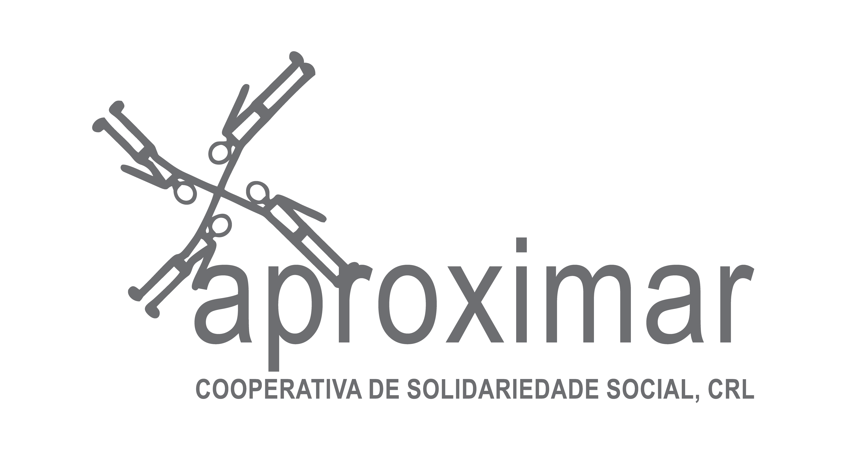

*We should use latest disclaimer in English and Greek (it is the one we copied above).* Funded by the European Union. Views and opinions expressed are however those of the author(s) only and do not necessarily reflect those of the European Union or the European Commission. Neither the European Union nor the European Commission can be held responsible for them.

**Business Development Training and Support for Non - Native Small Business Owners**